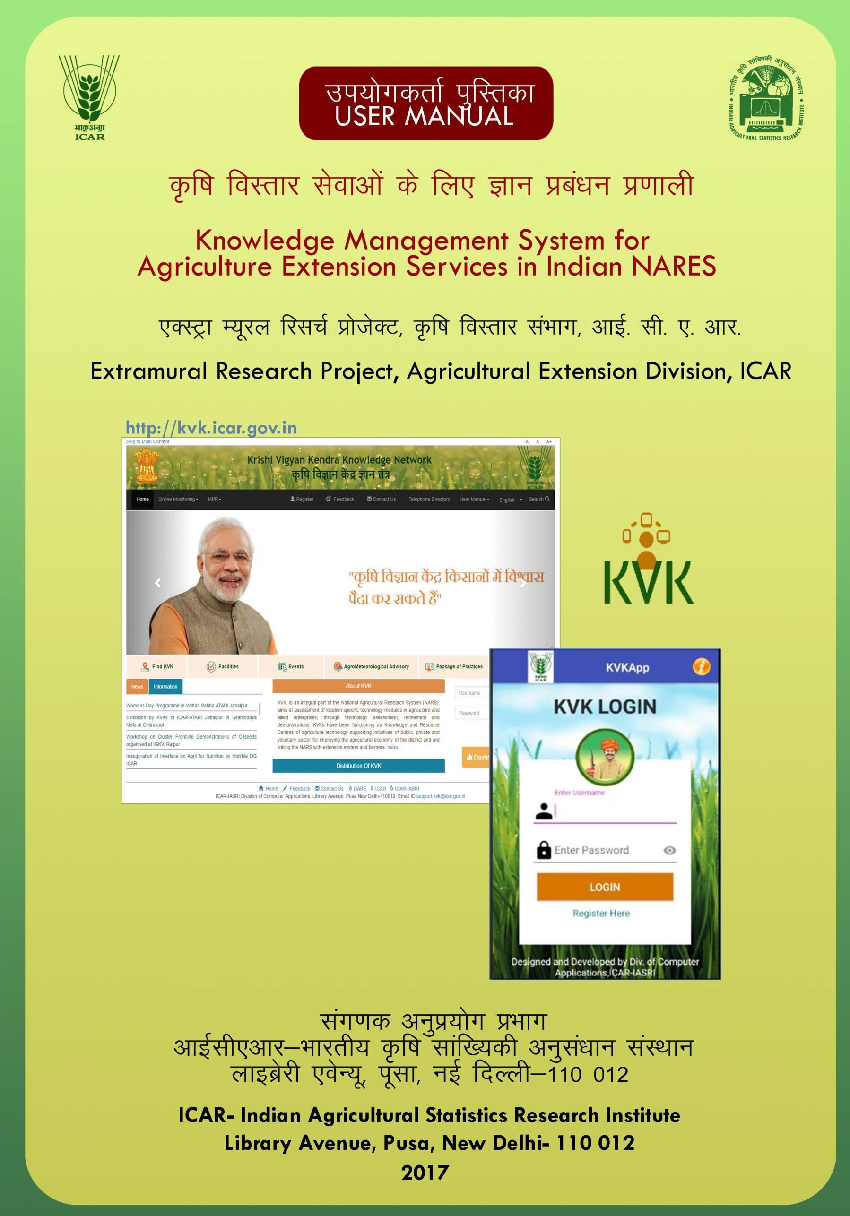

PROJECT TEAM
USER MANUAL FOR ATARI- KRISHI VIGYAN KNOWLEDGE NETWORK WEB PORTAL
USER MANUAL FOR KVK- KRISHI VIGYAN KNOWLEDGE NETWORK WEB

Division of Computer Applications, ICAR-IASRI

- Dr. Alka Arora

- Dr. A. K. Choubey

- Dr. Sudeep Marwaha

- Dr. Soumen Pal

- Dr. S. N. Islam

- Dr. N. Srinivasa Rao
Division of Agricultural Extension, ICAR-IASRI

- Dr. P. Adhiguru
Resource Persons from ATARI and KVK
- Dr. Anupam Mishra

- Dr. Prem Chand

- Sh. Satyabrata Ku Behera

KVK USER MANUAL
USER MANUAL FOR ATARI- KRISHI VIGYAN KNOWLEDGE NETWORK WEB PORTAL
USER MANUAL FOR KVK- KRISHI VIGYAN KNOWLEDGE NETWORK WEB

TABLE OF CONTENTS

Page No.

- INFORMATION ADDITION/ MODIFICATION BY KVK 4
  - 'KVK details Modification' Tab 4
  - 'Events' Tab 4
    - Add Events 5
    - Past Events Upload 6
  - 'Query Resolution' Tab 6
  - 'Upload Details' Tab 7
    - Achievements 7
    - Cluster Demonstrations 8
    - DBT 8
    - Facility Details 9
    - Farmers' Outreach 9
    - Farmer Details 10
    - KVK Profile Details 10
    - Land Assets 11
    - Package of Practices 11
  - Monthly Progress Report (MPR) Tab 11
  - Agricultural Extension- Monthly Progress Report (AE MPR) Tab 13

Information Addition/ Modification by KVK:
USER MANUAL FOR ATARI- KRISHI VIGYAN KNOWLEDGE NETWORK WEB PORTAL
USER MANUAL FOR KVK- KRISHI VIGYAN KNOWLEDGE NETWORK WEB
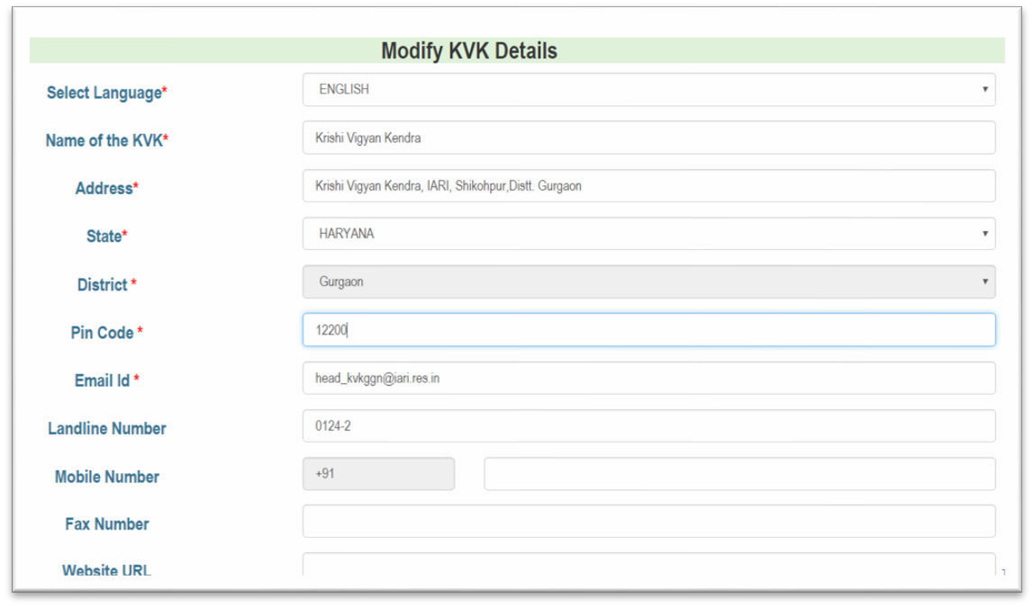The registered KVK and ATARI users can log in to the KVK portal by entering their Username and Password. Once they log in to the system, they can able to access the additional functionalities of the system. KVK has given the access to change user password. For doing this KVK has to enter old and new password.
KVK can add and update information regarding its organizational details. KVKs have to add information on events to be organized in the KVK, details of past events including upload of media files, description of facilities (including images) available in the KVK, package of practices (in local language), KVK profile details, Monthly Progress Report (MPR), Agricultural Extension MPR (AE MPR), details on Direct Benefit Transfer (DBT) under Field Level Demonstration (FLD) and On Field Trial (OFT) schemes, Cluster Field Level Demonstration (CFLD) and Pulses Seed Hub (selective KVKs) after logging in their respective accounts with the provided username and password.

‘KVK Details Modification’ Tab:

The basic information of KVK has already been pre-loaded into the system. However, KVK can add and update information regarding its organizational details (Fig. 1).

Fig: 1 KVK Details Modification

‘Events’ Tab:

The Event tab of the menu bar gives rights to KVK for adding information on KVK events and uploading past events media files.

    - Add Events: KVK can create, modify or delete an event by selecting start and end date, venue of an event (Fig. 2). Additionally, events can be created or modified in regional language (Fig. 3).
USER MANUAL FOR ATARI- KRISHI VIGYAN KNOWLEDGE NETWORK WEB PORTAL
USER MANUAL FOR KVK- KRISHI VIGYAN KNOWLEDGE NETWORK WEB

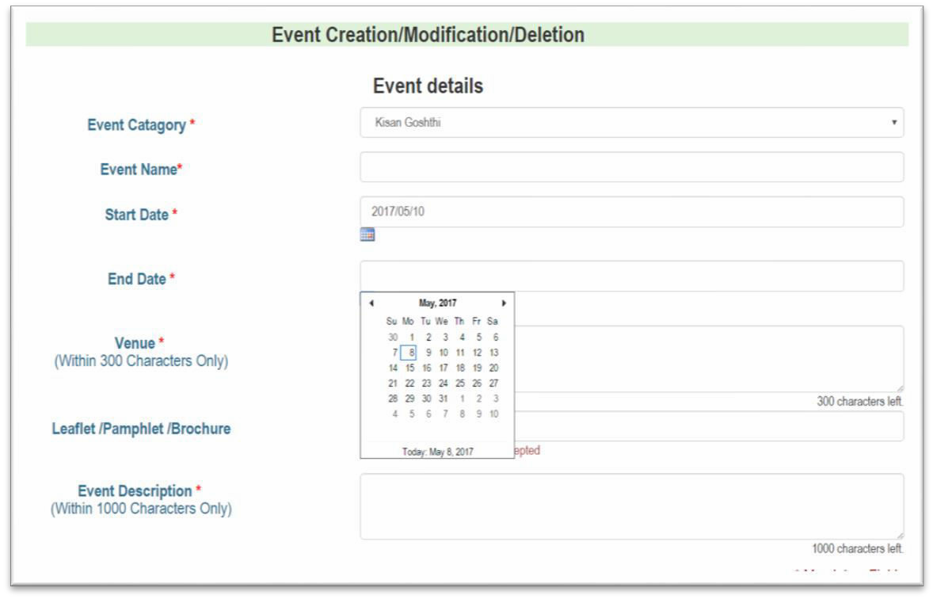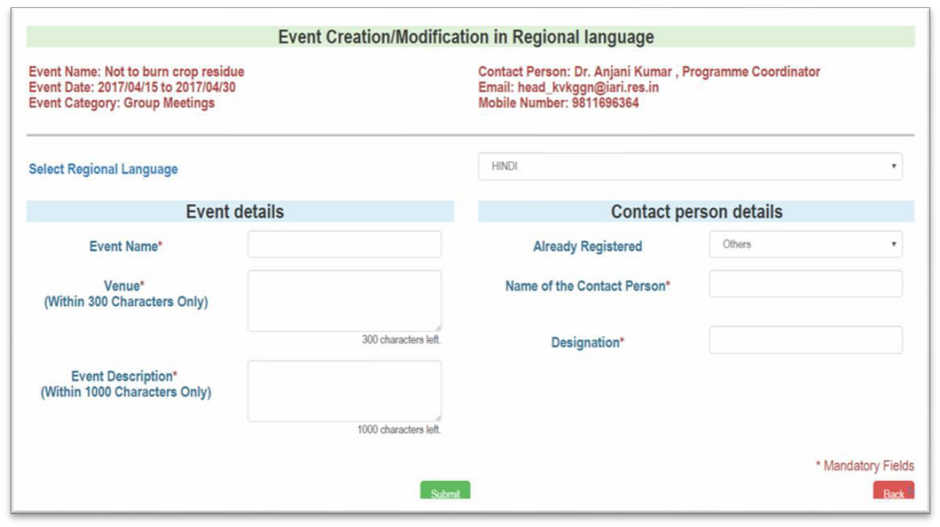
Fig: 2 Event Creation/Modification/Deletion

Fig: 3 Event Creation/ Modification in Regional language

    - 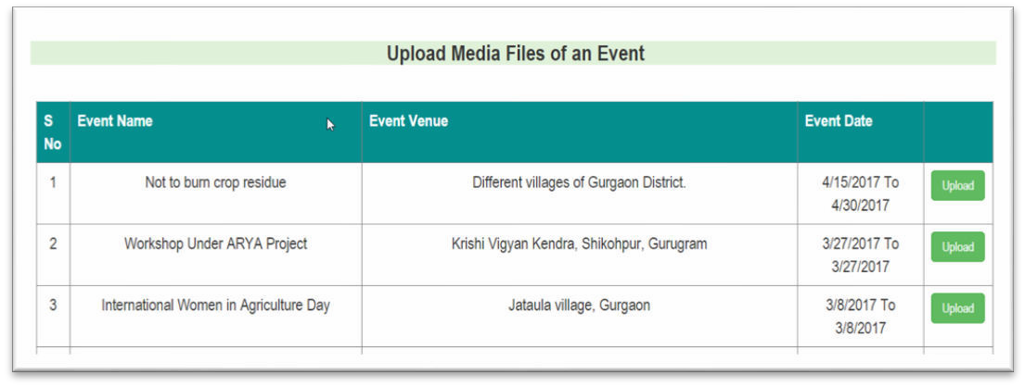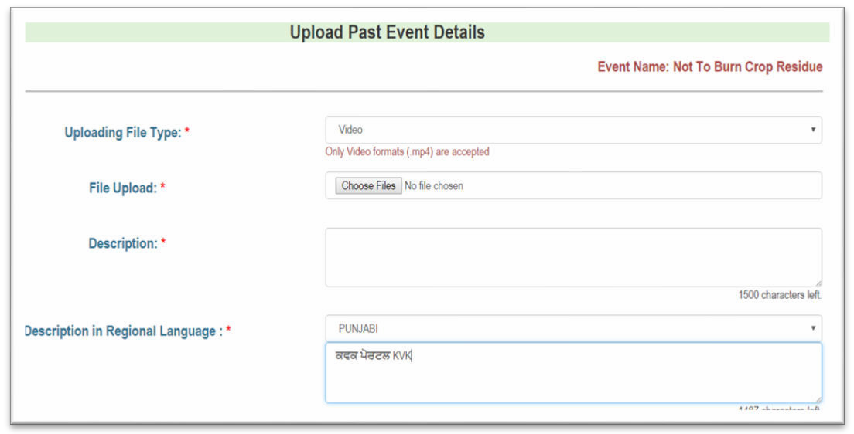Past Events Upload: The KVK can upload media files of a past event (Fig. 4), provided they have to give description in regional language (Fig. 5).
USER MANUAL FOR ATARI- KRISHI VIGYAN KNOWLEDGE NETWORK WEB PORTAL
USER MANUAL FOR KVK- KRISHI VIGYAN KNOWLEDGE NETWORK WEB

Fig: 4 Past Events Upload

Fig: 5 Details of Past Events Upload

‘Query Resolution’ Tab :
Whenever a farmer asks any query then the same is reflected in the respective KVK login. Screenshot from the respective KVK User Login Id has been displayed (Fig. 6). The KVK user can access the same and reply to farmer’s query and resolve them (Fig. 7). The answer is visible to the farmer after logging in their account in send query tab.

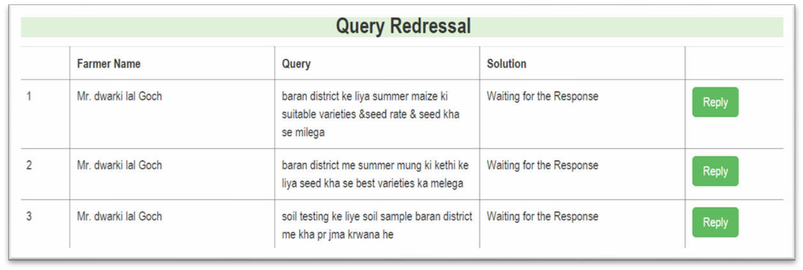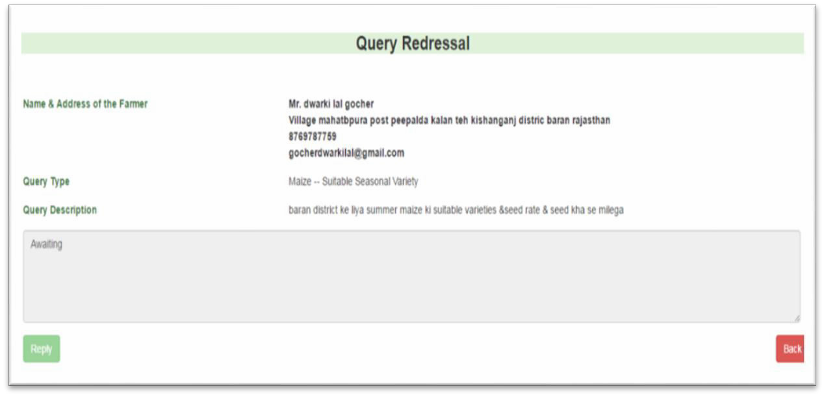USER MANUAL FOR KVK- KRISHI VIGYAN KNOWLEDGE NETWORK WEB
USER MANUAL FOR ATARI- KRISHI VIGYAN KNOWLEDGE NETWORK WEB PORTAL

Fig: 6 Query list

Fig: 7 Query Resolution

‘Upload Details’ Tab:

KVK will upload details regarding ‘Achievements’, ‘Cluster demonstrations’, ‘DBT’ information, ‘Facility Details’, ‘Farmer’s Outreach’, ‘Farmer Details’, ‘KVK Profile Details’, ‘Land Assets’ and ‘Package of Practices’.
    - Achievements: This tab enables KVK to save their achievements (in terms of product, technology and process). KVK has to enter all the mandatory details including item, technology adoption (area and no. of farmers), product, and process (Fig. 8).

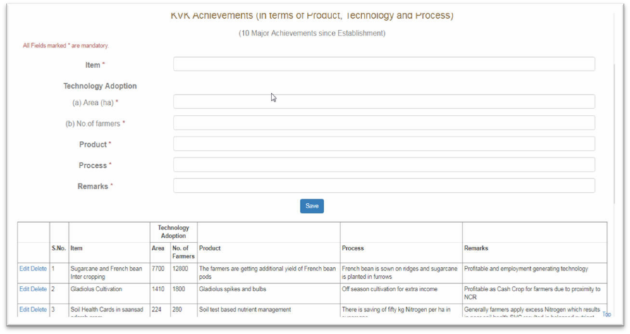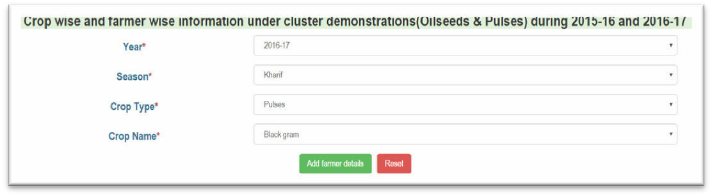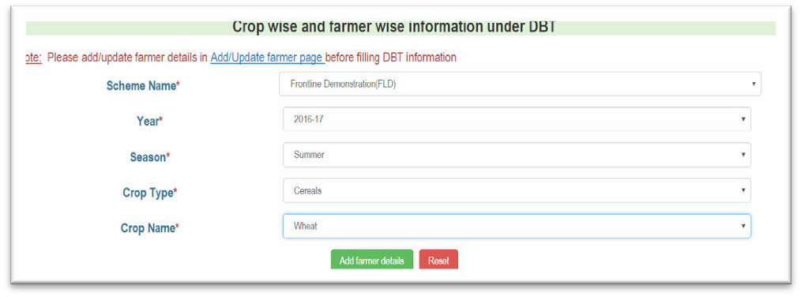USER MANUAL FOR KVK- KRISHI VIGYAN KNOWLEDGE NETWORK WEB
USER MANUAL FOR ATARI- KRISHI VIGYAN KNOWLEDGE NETWORK WEB PORTAL

Fig: 8 Achievements

    - Cluster Demonstrations: It provides crop wise and farmer wise detail information for a particular year including pulses and seed hub (Fig. 9).

Fig: 9 Upload Details-> Cluster Demonstrations

    - DBT (Direct Benefit Transfer): Crop wise and farmer wise information under DBT is added using this facility (Fig. 10).

Fig: 10 DBT

    - 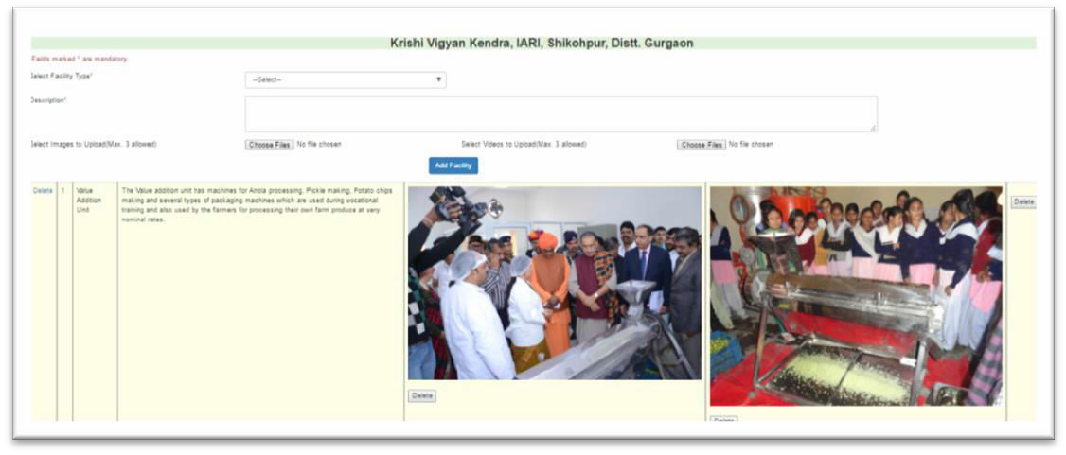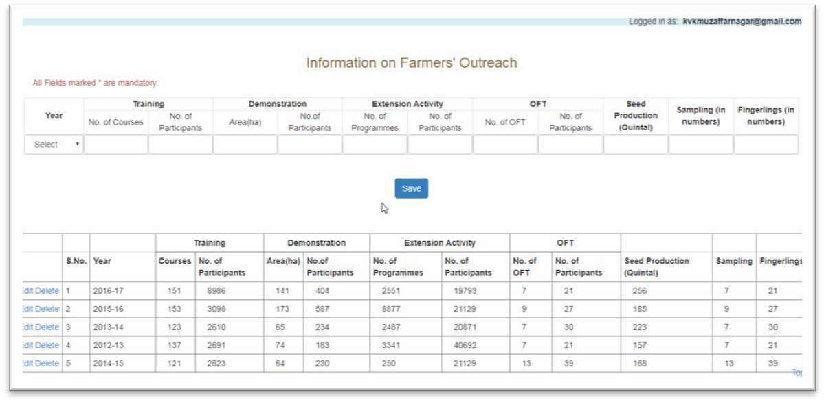Facility Details: Various facilities with their description are added/uploaded under Facility Details by the KVK (Fig. 11).
USER MANUAL FOR ATARI- KRISHI VIGYAN KNOWLEDGE NETWORK WEB PORTAL
USER MANUAL FOR KVK- KRISHI VIGYAN KNOWLEDGE NETWORK WEB

Fig: 11 Facility Details

    - Farmers’ Outreach: This option enables KVK to save the information available on farmers’ outreach for a particular year (Fig. 12). KVK will be able to save no. of participants for training, demonstration, extension activity, and OFT. KVK can save seed production, sampling and fingerlings (in numbers) which will be visible in grid form.

Fig: 12 Farmers’ Outreach

    - 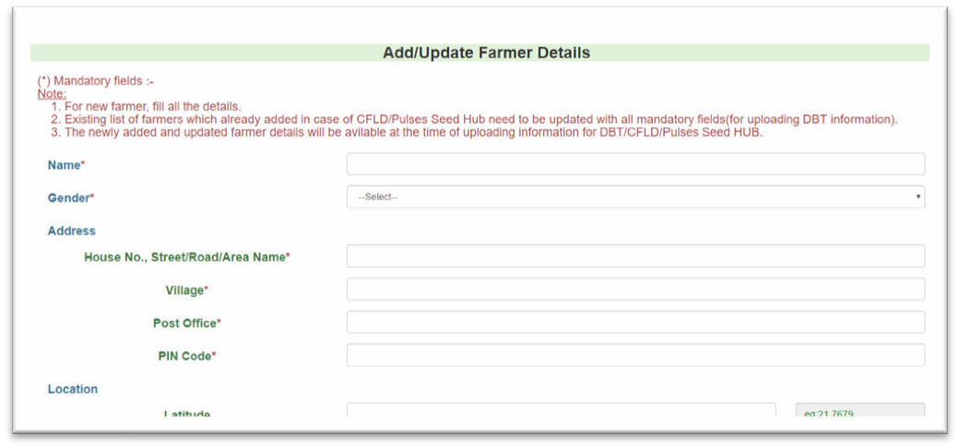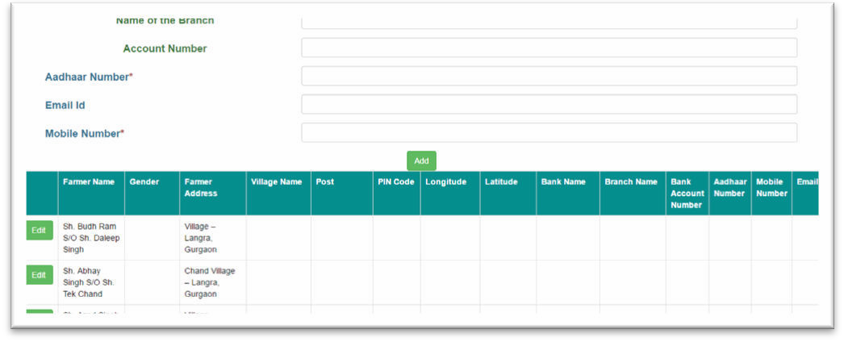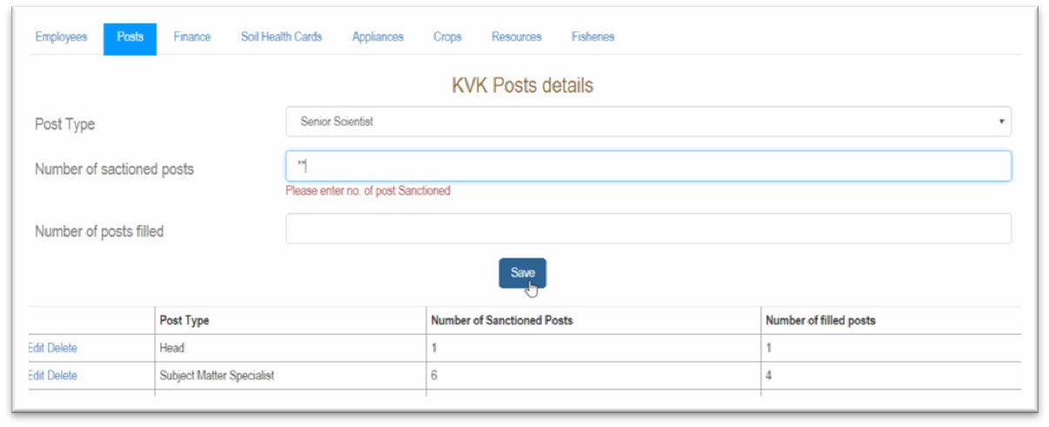Farmer Details: Farmer details will be added after filling all the required fields incorporating name, gender, address, aadhaar and mobile number (Fig. 13). Farmer can also change his details as this facility has been provided to the farmer to edit his credentials.
USER MANUAL FOR ATARI- KRISHI VIGYAN KNOWLEDGE NETWORK WEB PORTAL
USER MANUAL FOR KVK- KRISHI VIGYAN KNOWLEDGE NETWORK WEB

Fig: 13 Farmer Details

    - KVK Profile Details: Profile details of KVK (Fig. 14) includes uploading information of Employees, Posts, Finance, Soil Health Cards, Appliances, Crops, Resources, and Fisheries.

Fig: 14 KVK Profile Details

    - 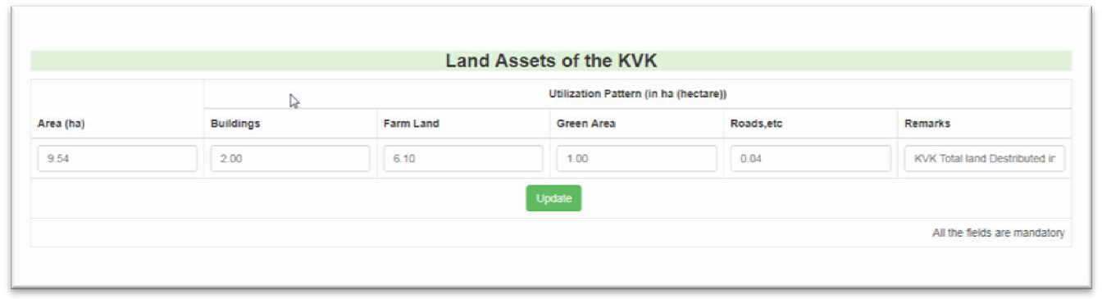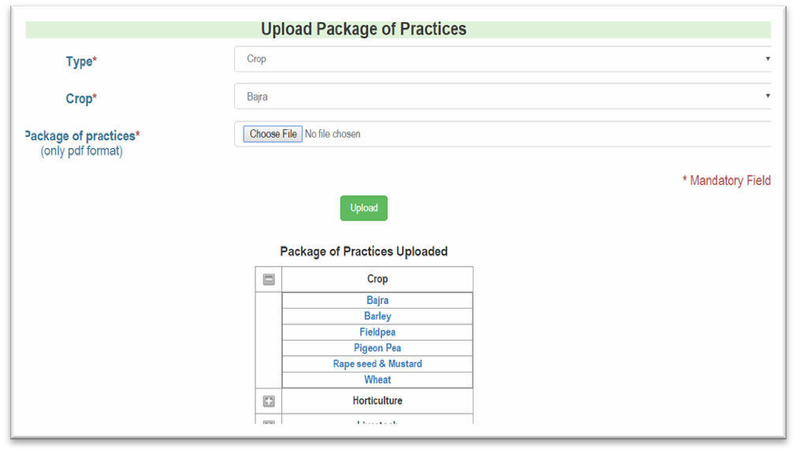Land Assets: The ‘land assets’ tab enables KVK to update information regarding its Area with utilization pattern (in hectares) that includes buildings, farm land, green area, and roads, etc (Fig. 15).
USER MANUAL FOR ATARI- KRISHI VIGYAN KNOWLEDGE NETWORK WEB PORTAL
USER MANUAL FOR KVK- KRISHI VIGYAN KNOWLEDGE NETWORK WEB

Fig: 15 Land Assets

    - Package of Practices: Package of Practices may be uploaded for the type ‘crop’, ‘fisheries’, ‘horticulture’ and ‘livestock’(Fig. 16).

Fig: 16 Package of Practices

‘Monthly Progress Report (MPR)’ Tab:

MPR (Monthly Progress Report) form is provided to KVK to automate the monthly reporting of KVK progress to ATARI. Using new entry tab the data for a particular month (Fig. 17) in a year can be filled up (Fig. 18). For updating and viewing of submitted data, additional edit and view tabs are provided.

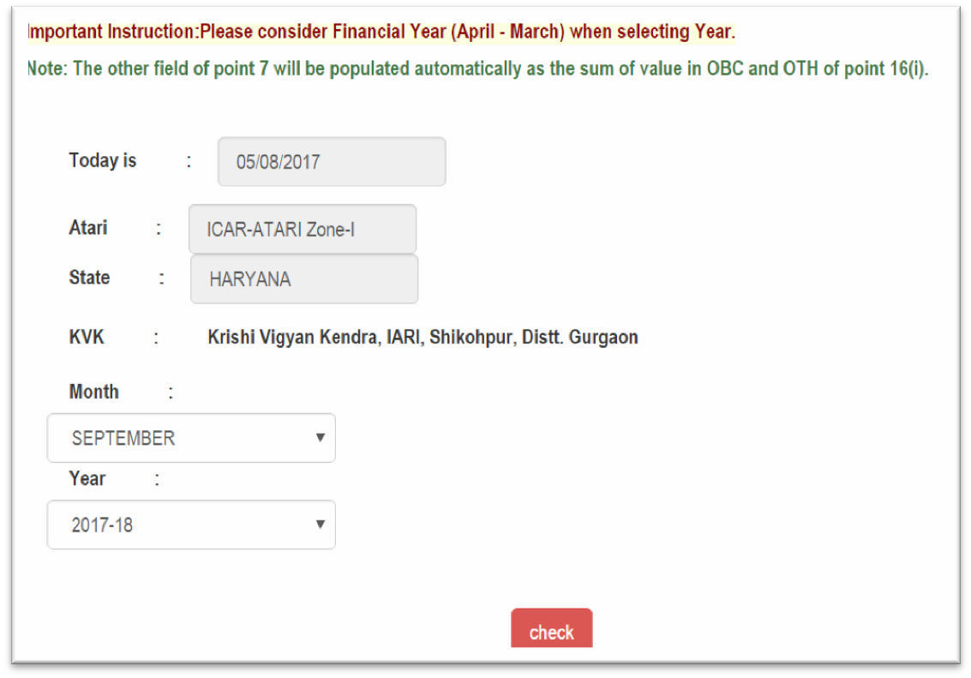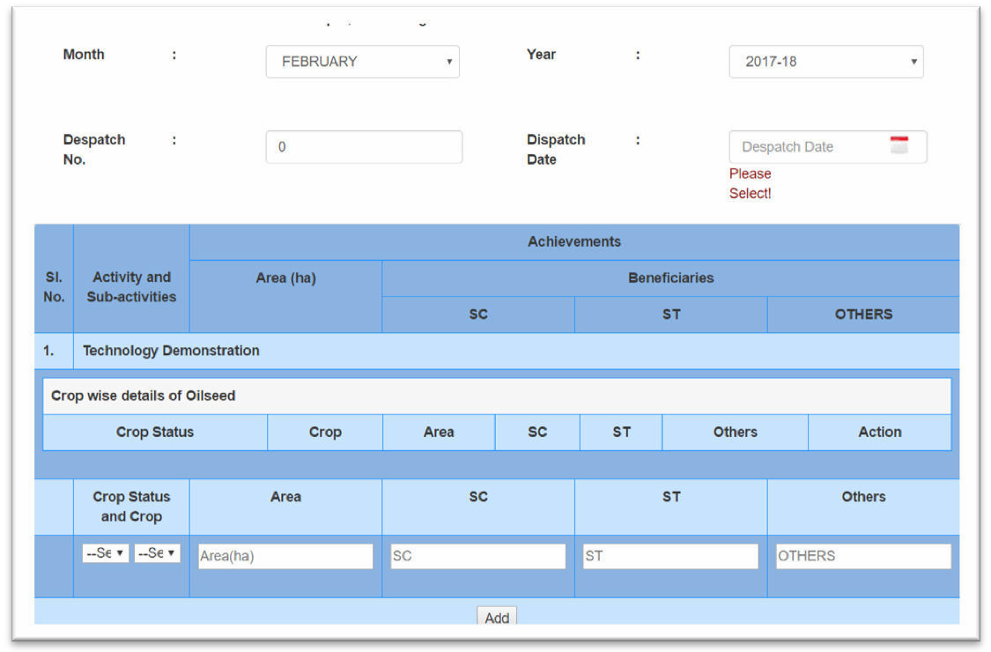USER MANUAL FOR KVK- KRISHI VIGYAN KNOWLEDGE NETWORK WEB
USER MANUAL FOR ATARI- KRISHI VIGYAN KNOWLEDGE NETWORK WEB PORTAL

Fig: 17 MPR

Fig: 18 MPR

‘Agricultural Extension- Monthly Progress Report (AE MPR)’ Tab:
USER MANUAL FOR ATARI- KRISHI VIGYAN KNOWLEDGE NETWORK WEB PORTAL
USER MANUAL FOR KVK- KRISHI VIGYAN KNOWLEDGE NETWORK WEB

KVK has given the access to upload information in Agricultural Extension- Monthly Progress Report (AE MPR) for a particular month (Fig. 19). It will be filled by selecting ‘AE MPR’ tab in the menu bar. KVK can edit and view AE MPR.

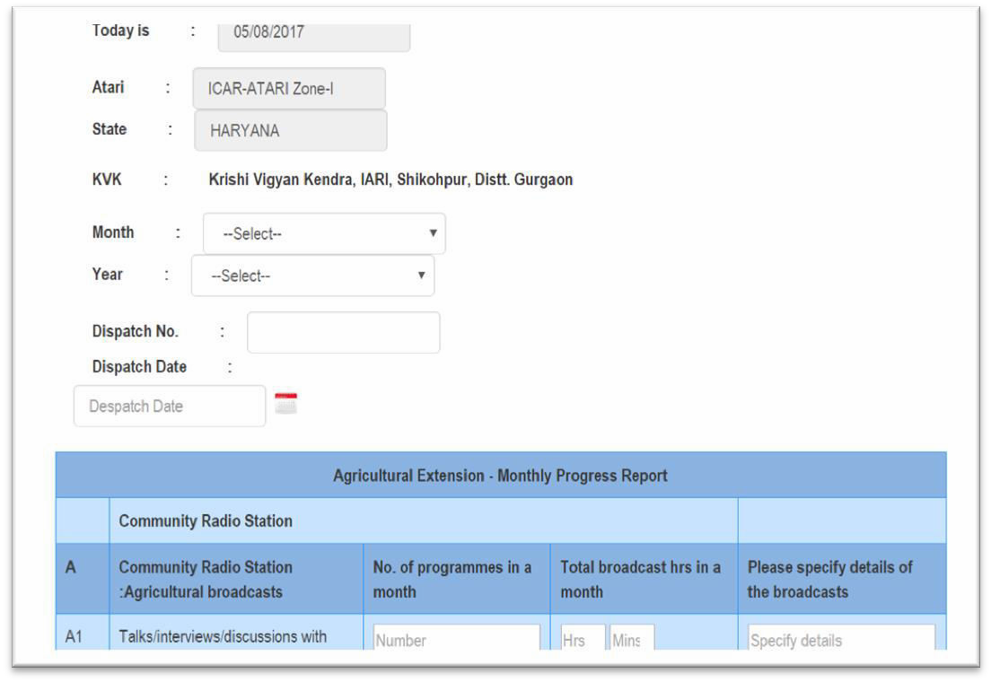
Fig: 19 AE- MPR

